DOCKER

1. A virtual Machine has guest operating system, and a container image does not have container image
2. Containers = Virtual machine – Operating system

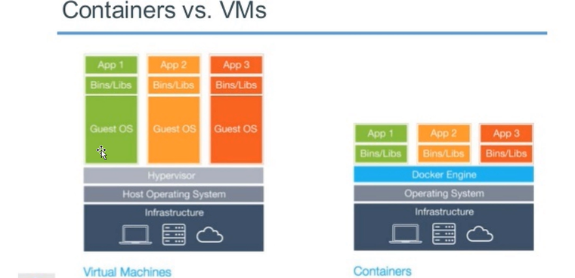

1. The applications have dependencies on particular server or any particular O.S like web server and if it is a Java application and if it has to work it requires TOMCAT server and if it is .dot net application it requires cluster server and if it is .dotnet framework application it requires IAAS Webserver
2. Container is initiated from image and if an image Is deployed in target machine automatically all the required will be taken care from the image
3. On my machine I might have .dotnet framework/.dotnet coresdk and I have developed my application in .dotnet core I build my application and package my application and all those things we can do in the form of image
4. When I want to run this image on your machine the only thing we need is installation of Docker
5. Docker is an engine which is responsible for converting your request from application to underline host kernel. Communication between application containers and O.S will be done docker. Images are 0.S specific if you use windows then you should use the windows only
6. Containerization is all about creating containers from an image so that each container will have its own file system and its own IP address, OWN applications, own dependencies will have own configuration file which remains complete isolation with underline o.s and the other containers which are running on machine

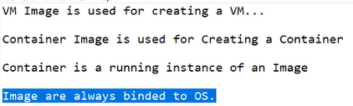

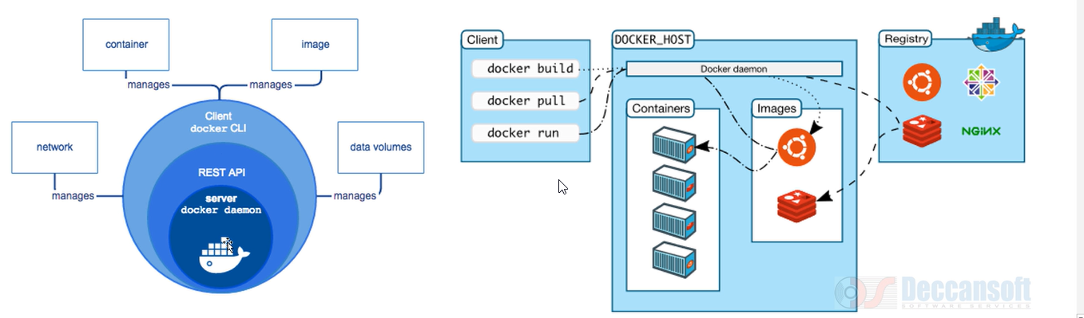

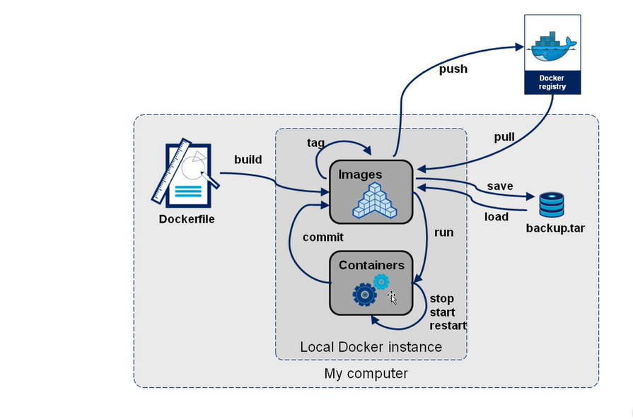

Docker images is the command for creating the docker images and if the images are already there then it will show like this

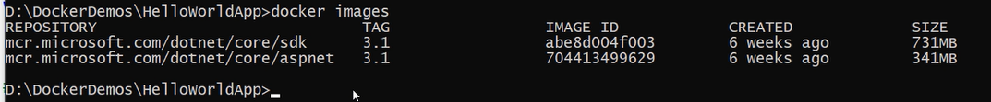

Create a file in my project which is called docker file. It is a file which has all the instructions required for our application

We need to put the docker file under the root

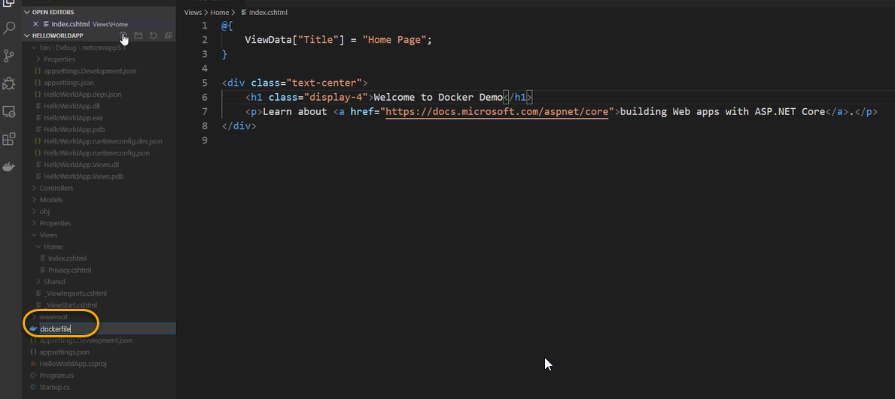

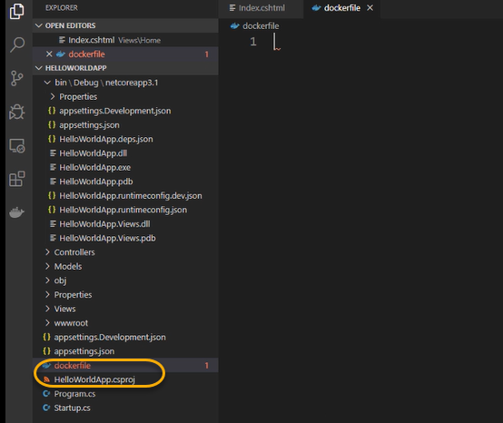

Docker file is an instruction set for creating a docker image and the first statement begins with FROM

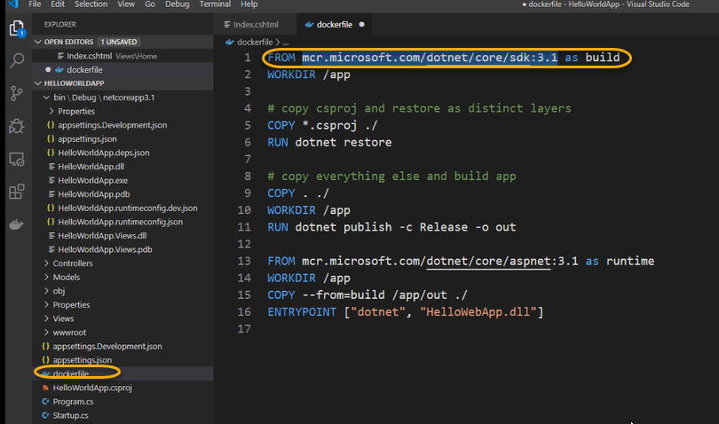

docker build -t Docker hub account name/repository name: v1(tag) .(path of the docker file right now docket file is in the current directory) simply put . (dot)

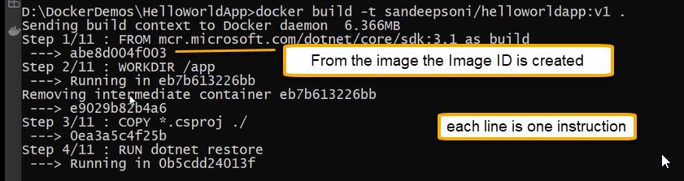

Step 2/11 From that image new container is created where we are going to have a directory created /app

Step 3/11 in that directory my cs proj file is copied at every stage/step a new container instance is created

That container is persistent and creating as the image and that image is used for creating another container

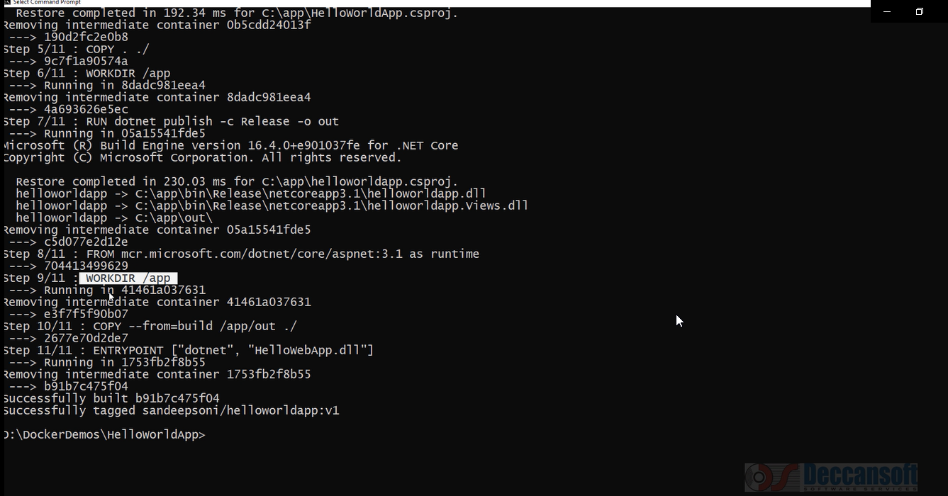

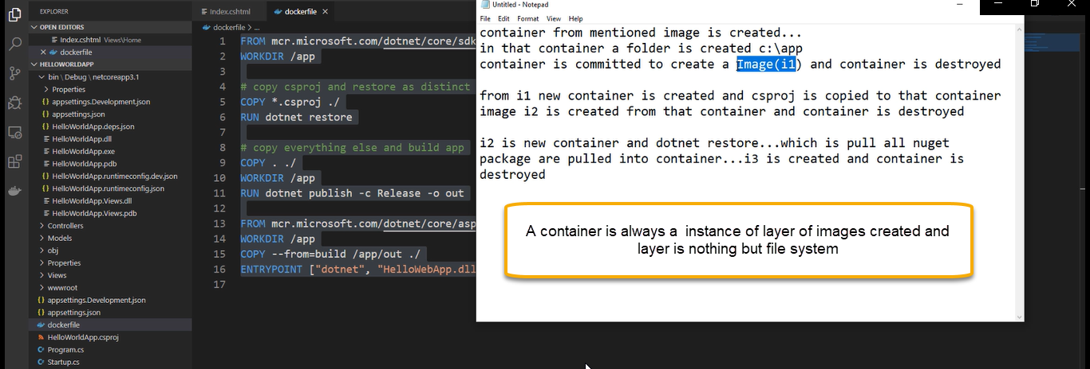

The docket file is a multistage file

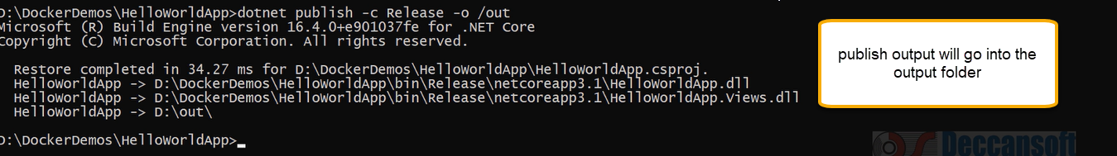

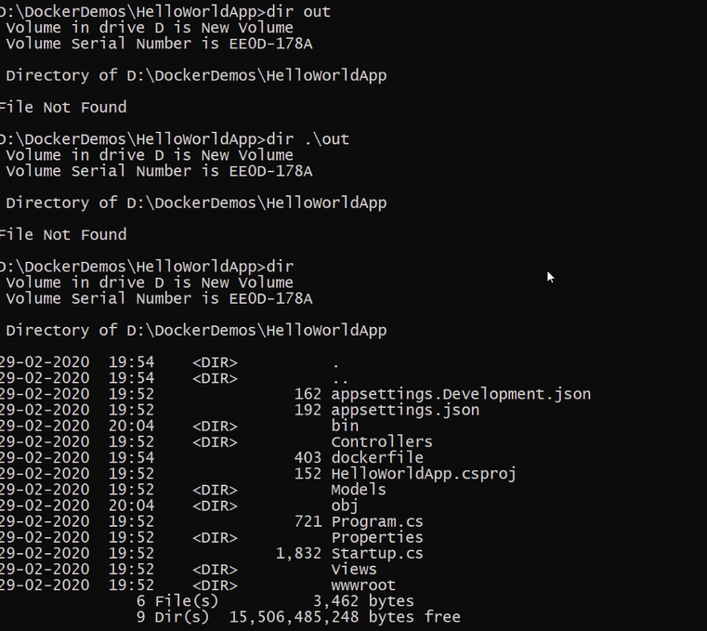

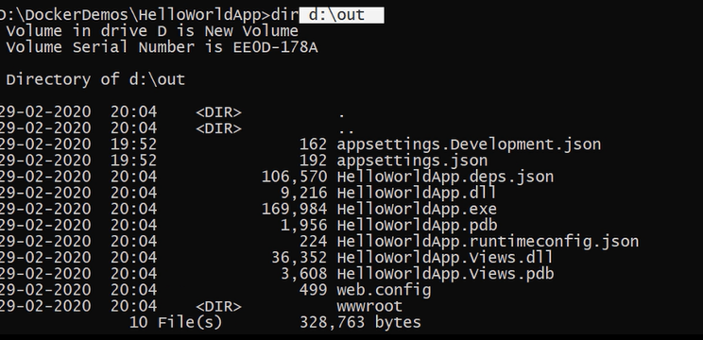

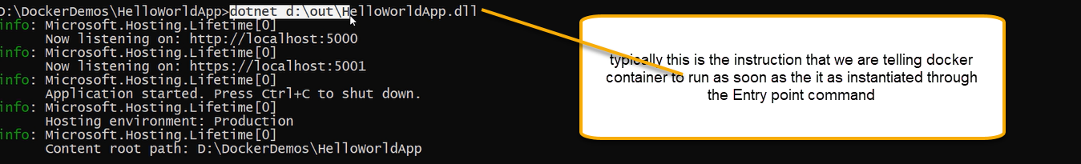

Docker file is used by docker build for creating the layer of images where the final image is given as a tag as specified in docker build command

And always image is based on base image

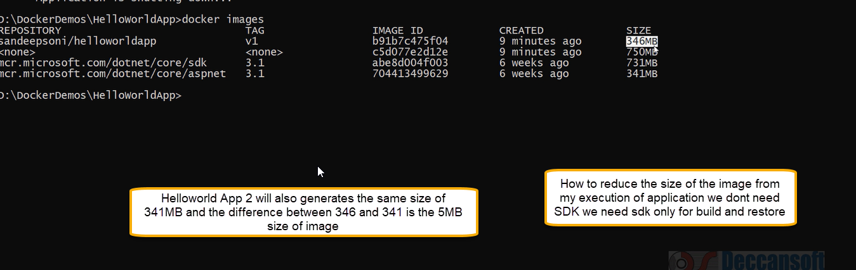

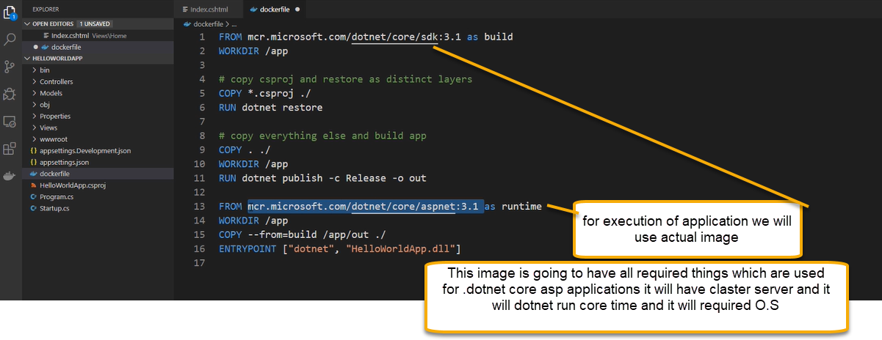

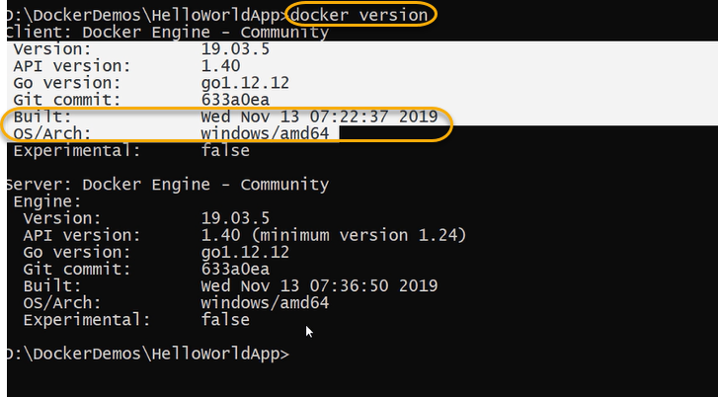

If you want to create docker image we can create and it is possible only in windows 10 machine

When you install docker on your machine

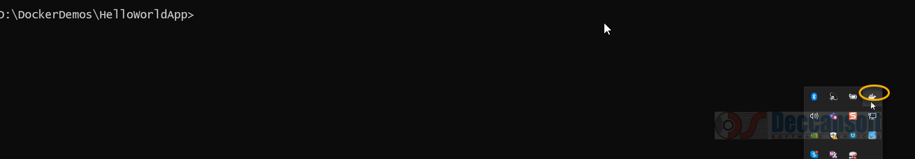

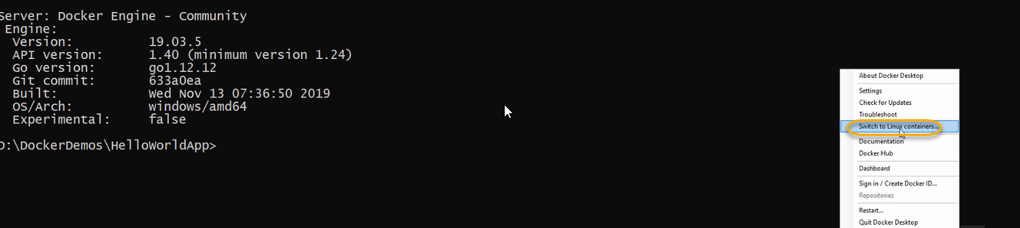

Now if you run docker version the client will be windows and the server will be linux

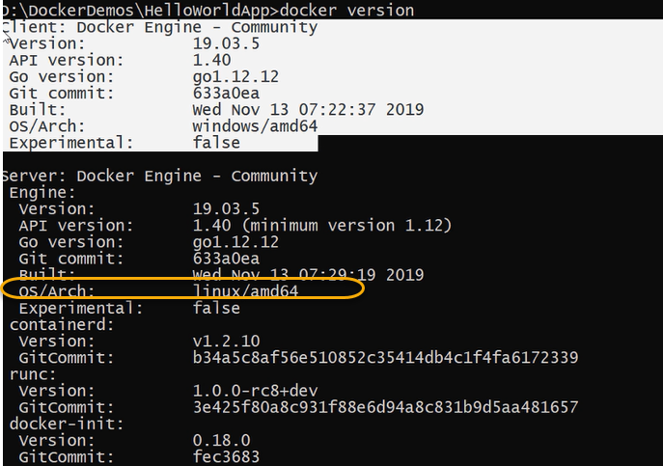

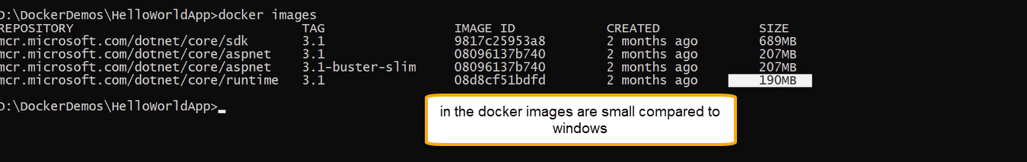

If you run the docker build in linux same steps will be carried out

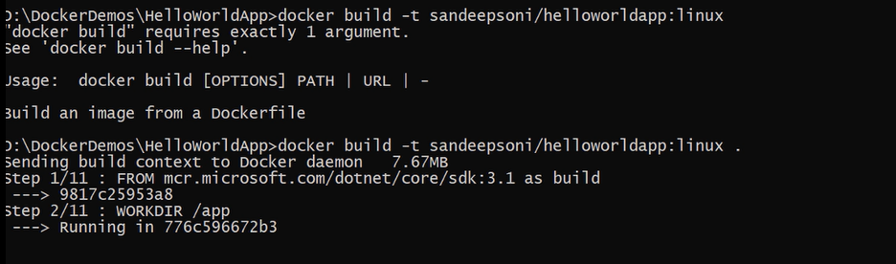

Once the image is created, we need to push that image into docker hub

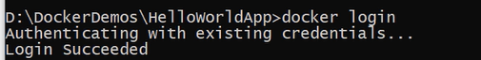

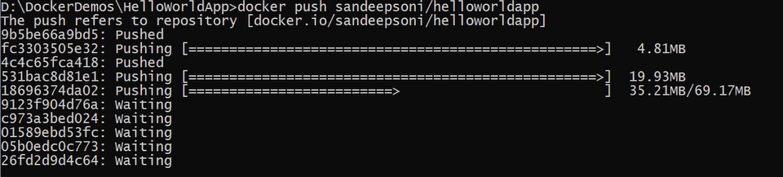

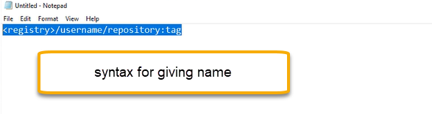

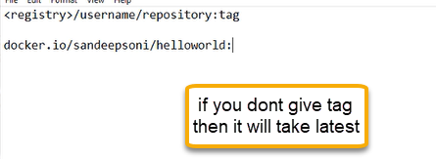

Run the docker images

It will take the latest

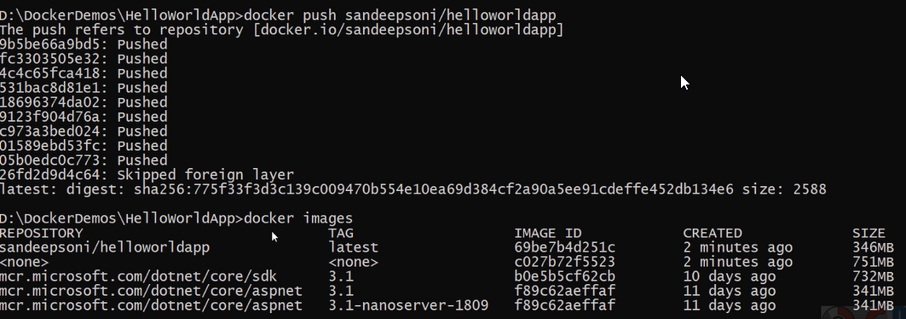

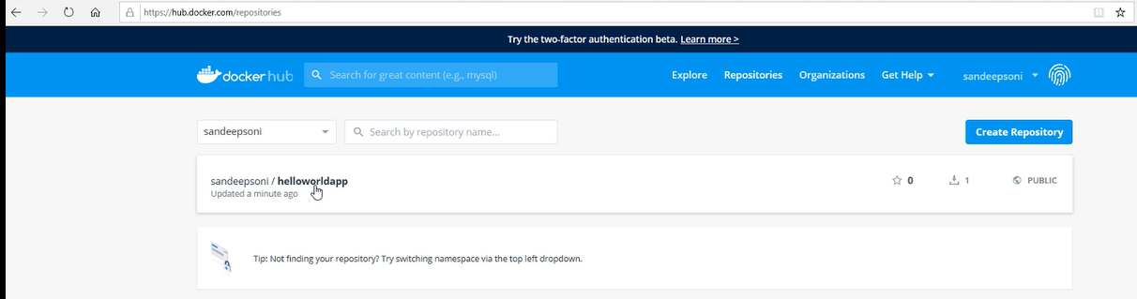

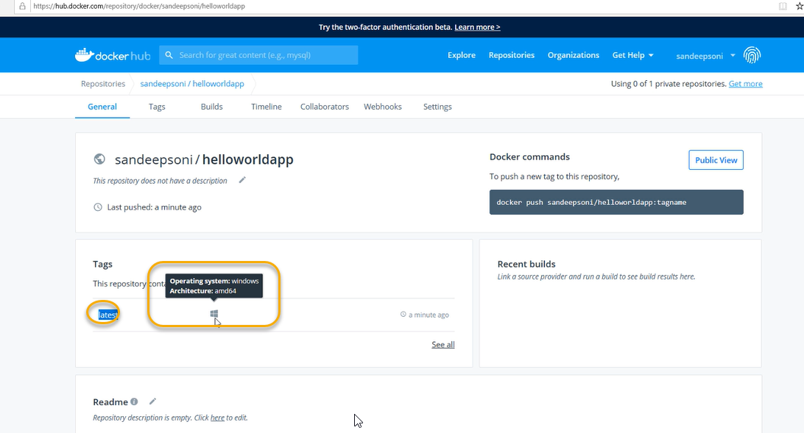

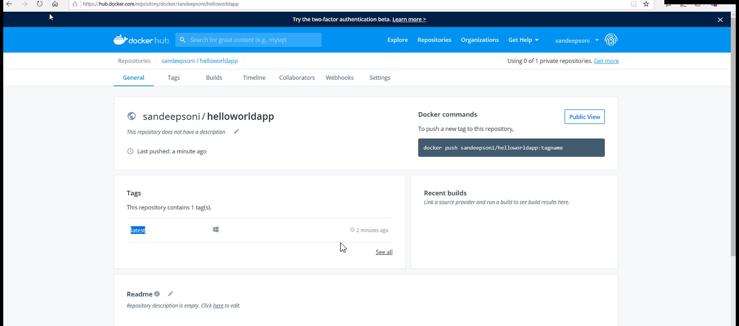

If you want, we can create a tag then we can create a tag

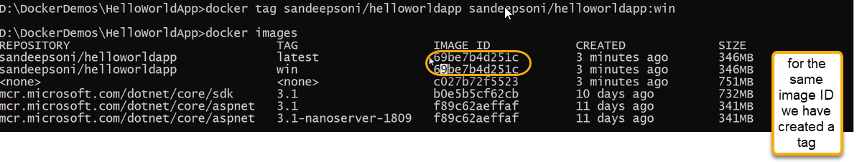

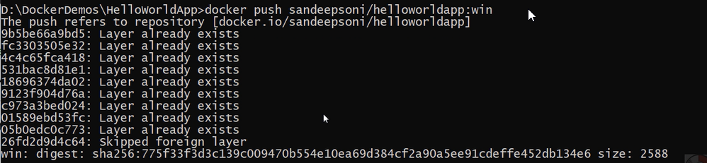

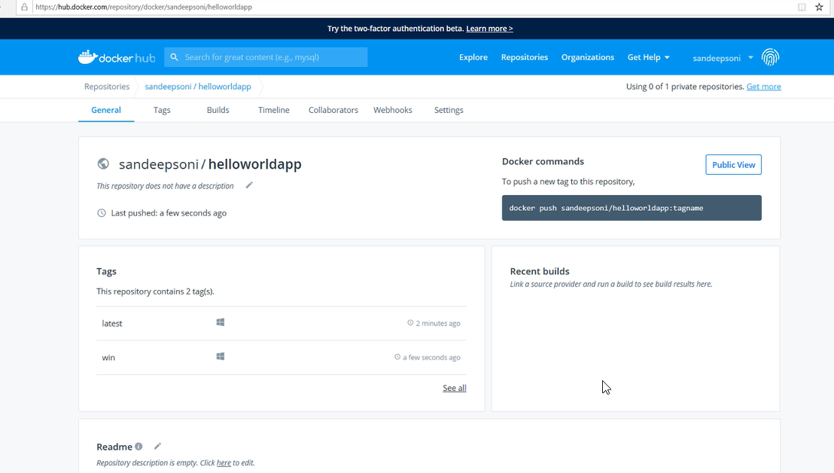

For linux

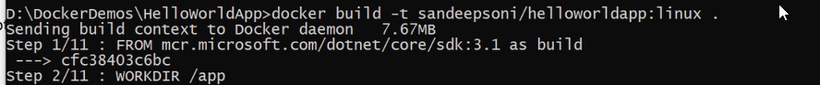

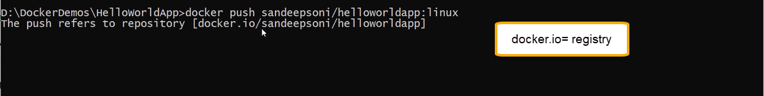

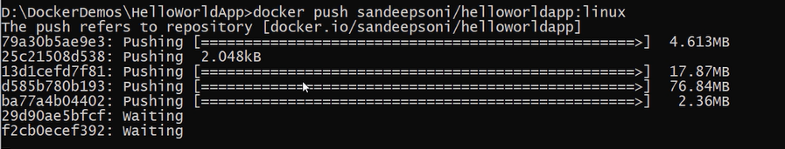

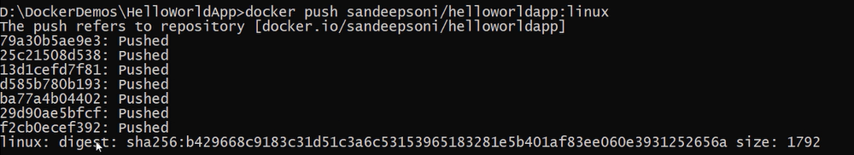

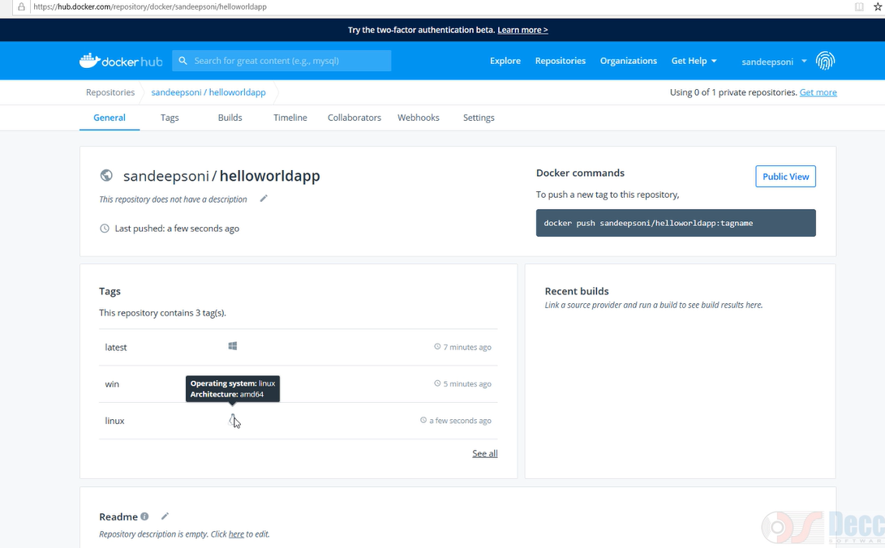

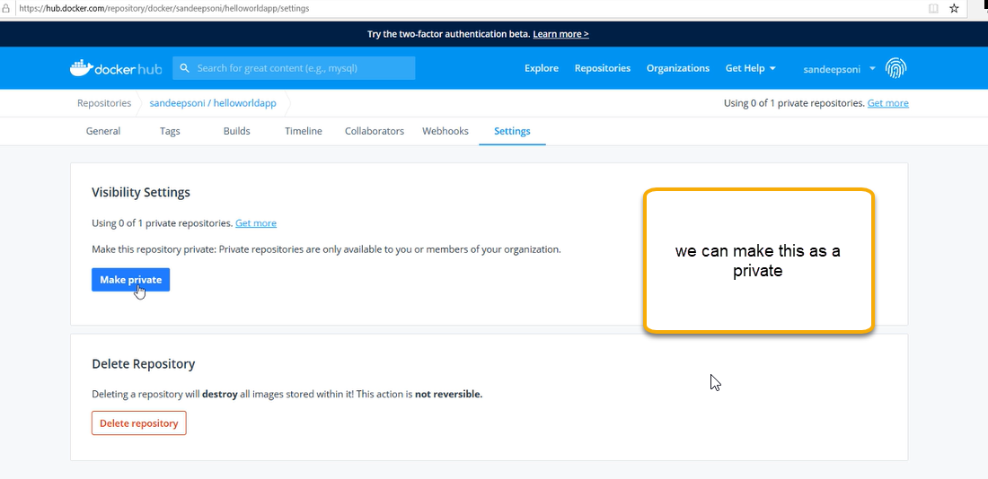

We can push the same thing in the Azure container registration

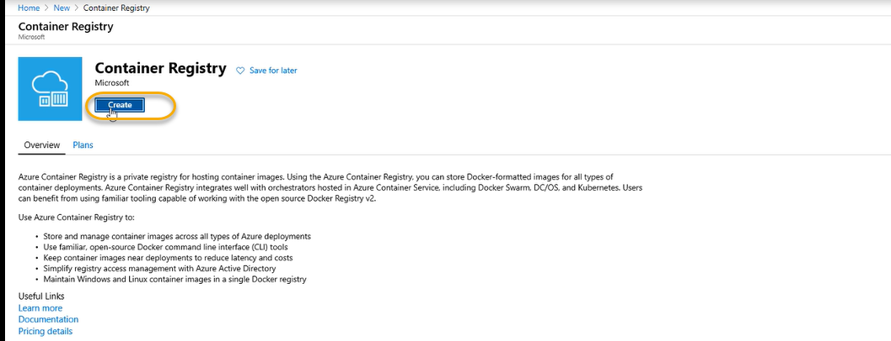

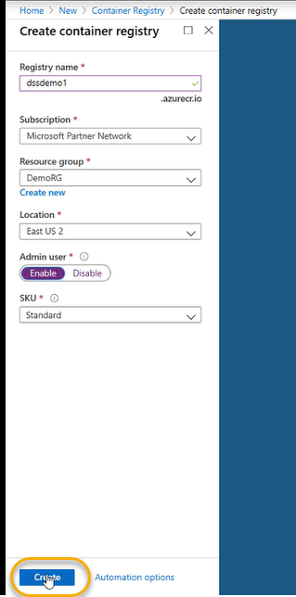

Now switch from linux to windows

Now change the tag name

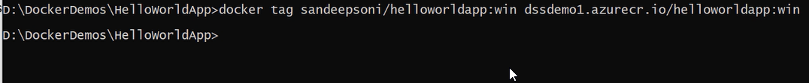

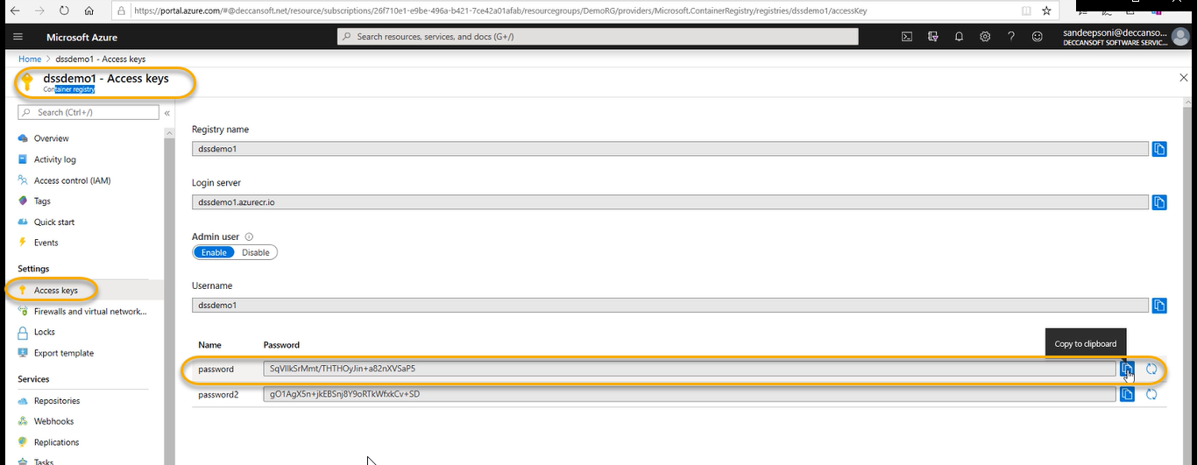

For azure to login we need to give username, password and url of azure container registry



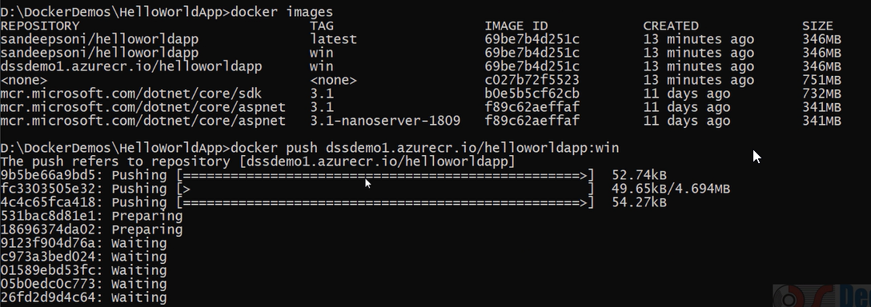

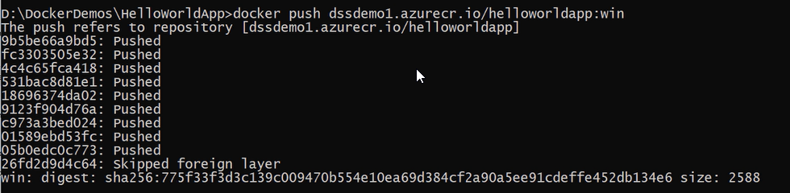

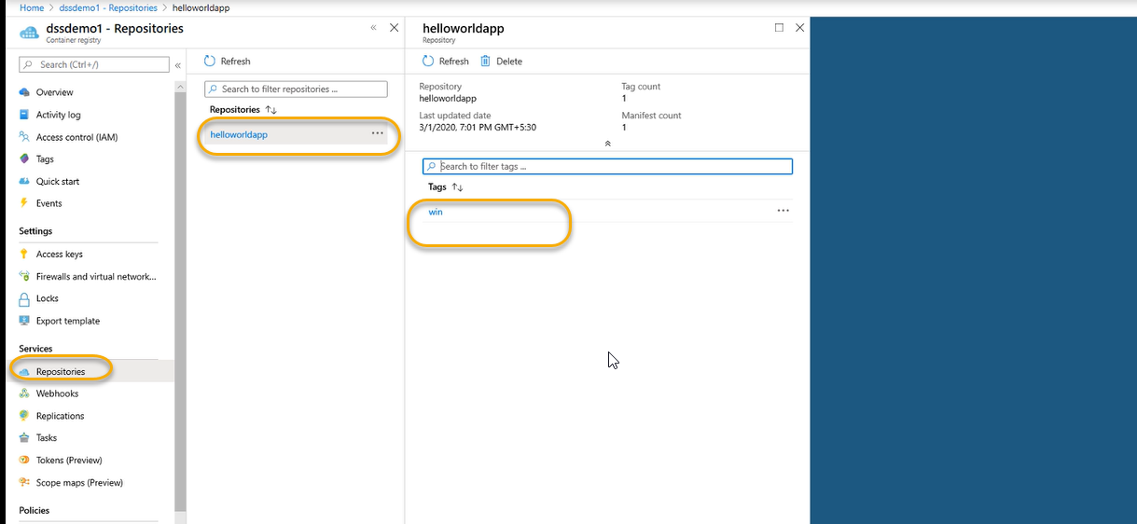

We can do the same for the linux

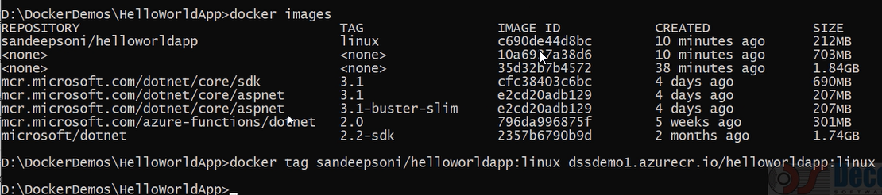

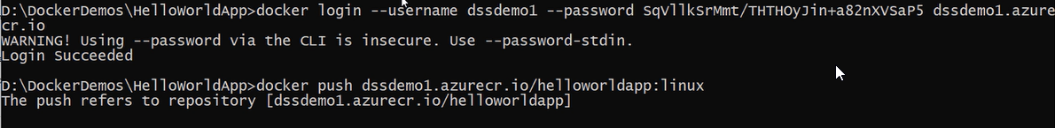

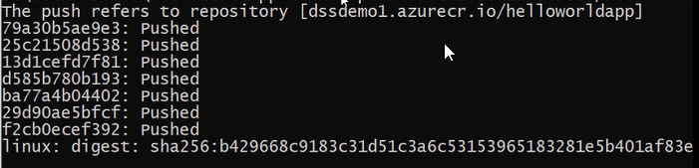

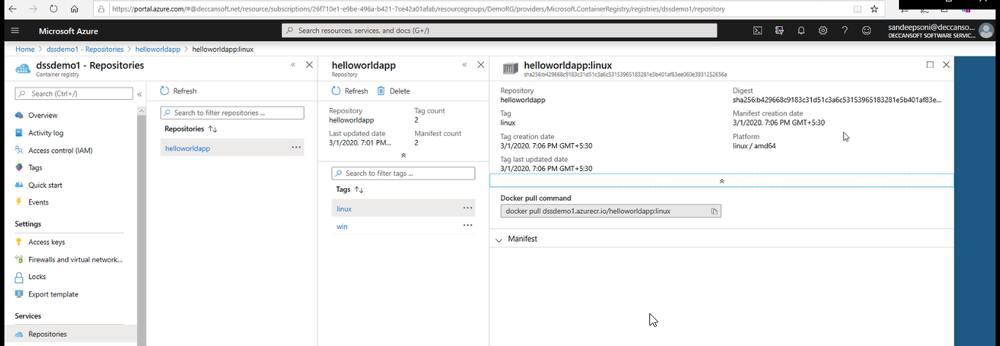

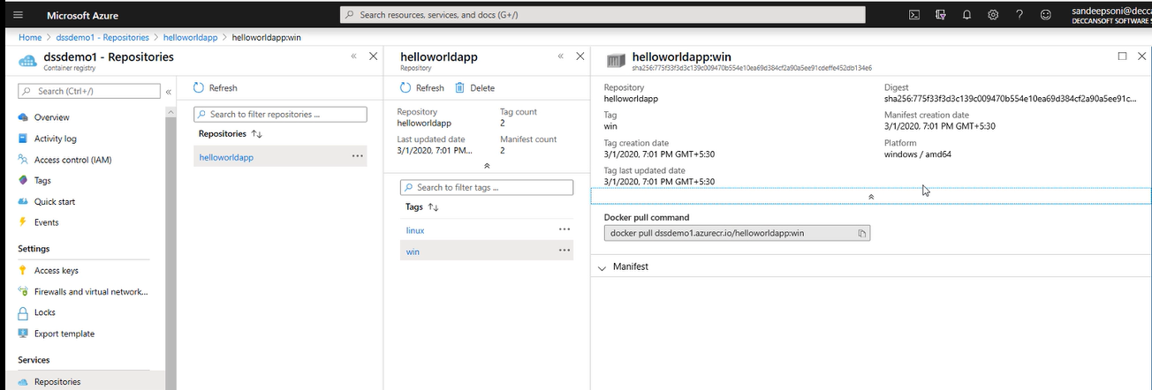

Images generated as of now

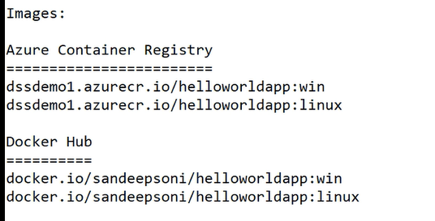

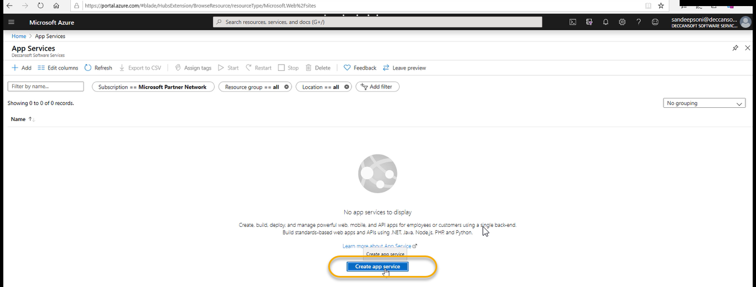

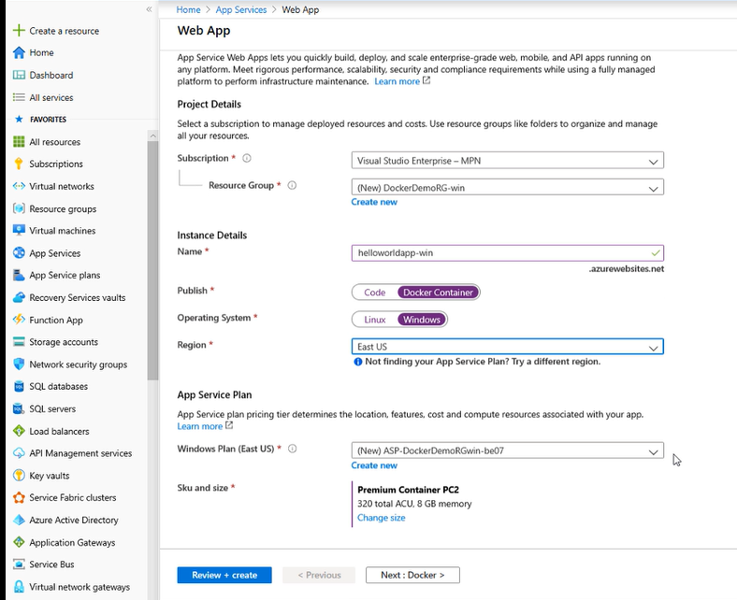

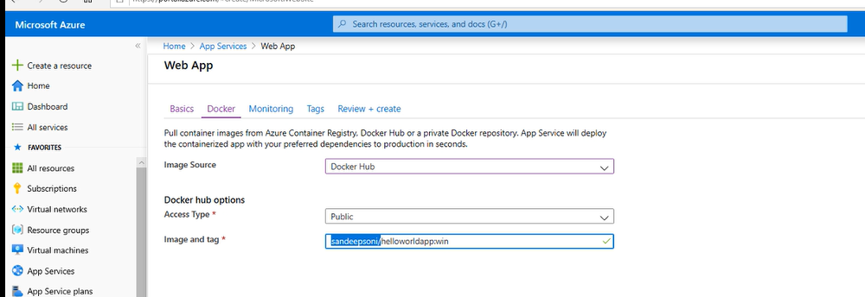

Image and tag we can get from the images

Click on Review+create and then click on create

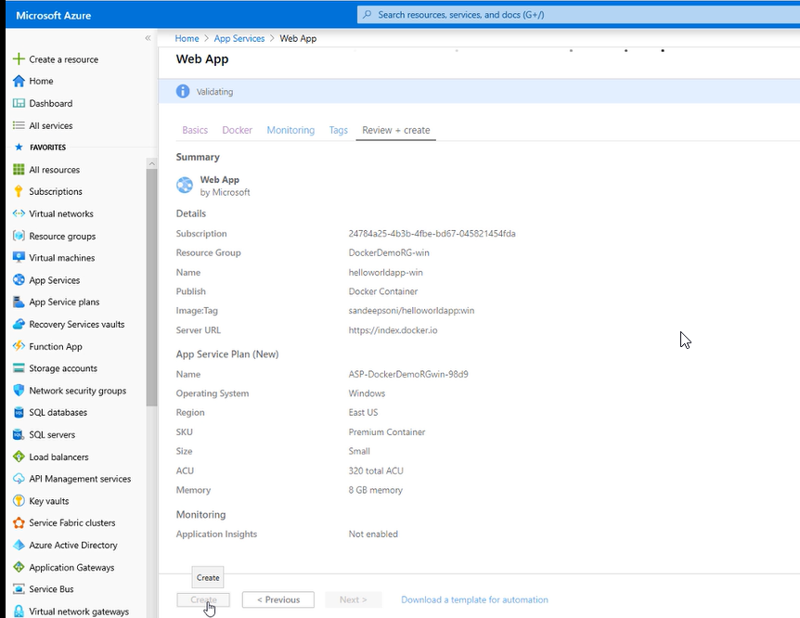

For linux

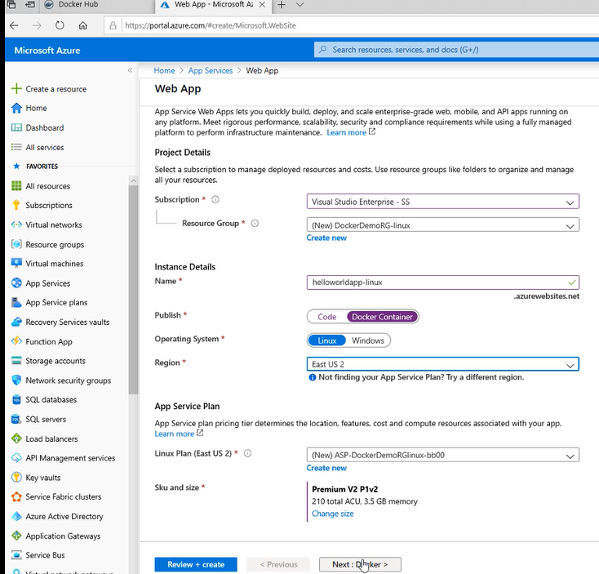

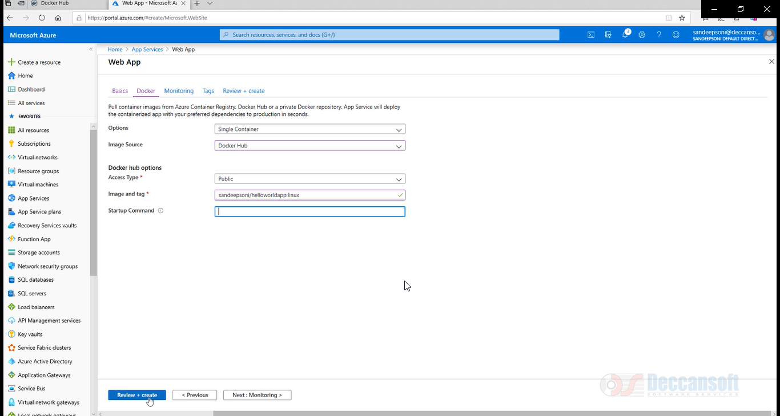

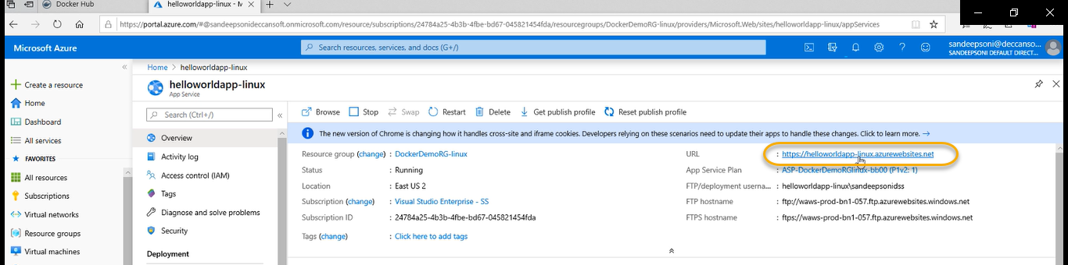

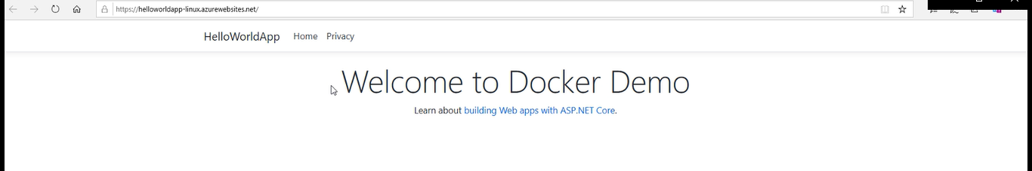

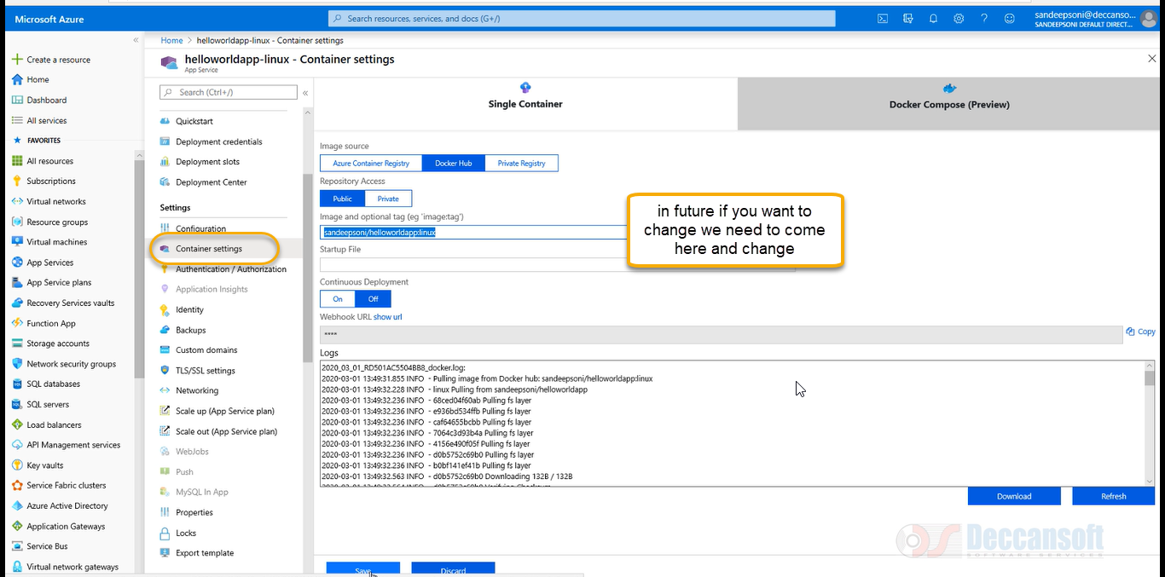

FOR WINDOWS

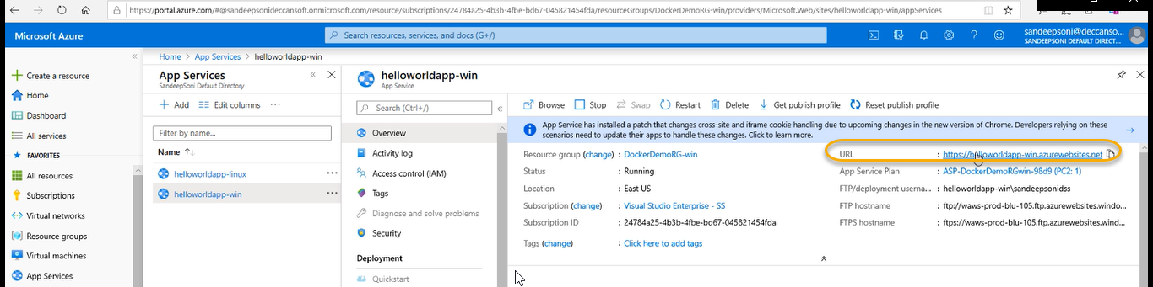

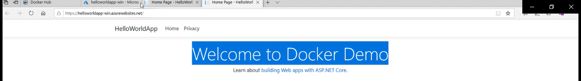

If you need to do some changes and we need to access the URL just swap it and stage it and access the url

We can create azure container instance it is a light weight virtual machine containers are created with out VM

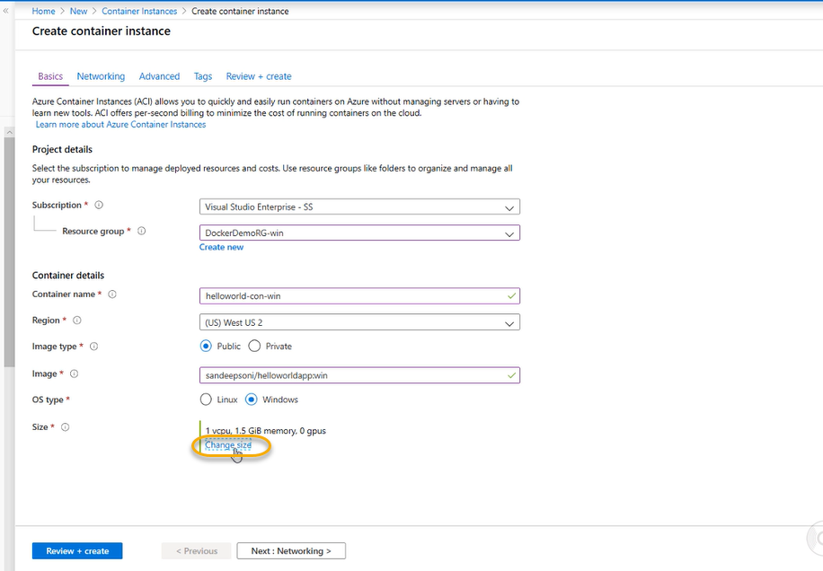



Select the default options and click on Review + create

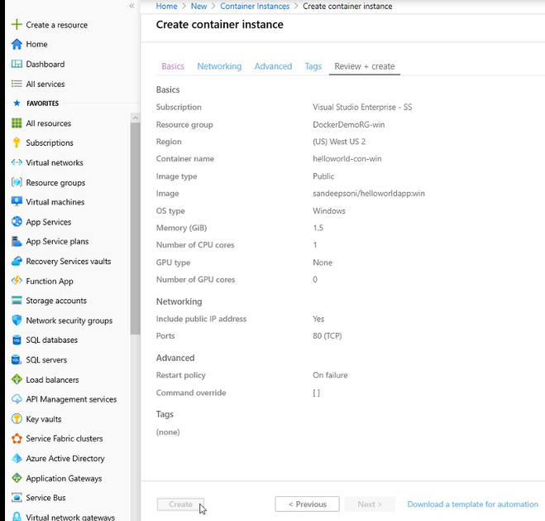

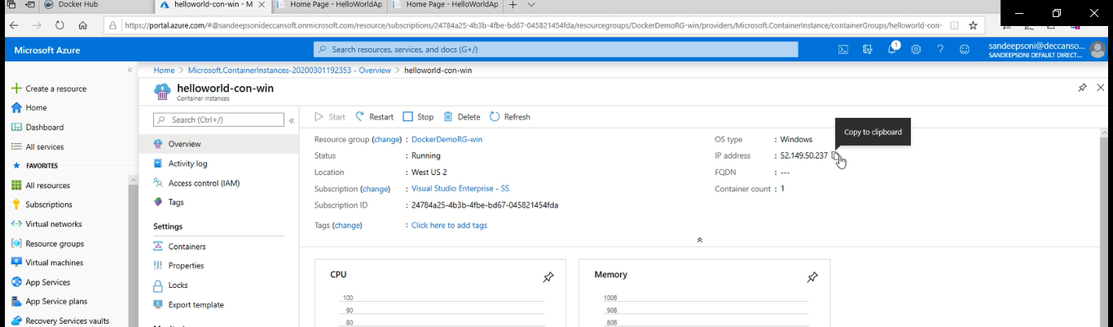

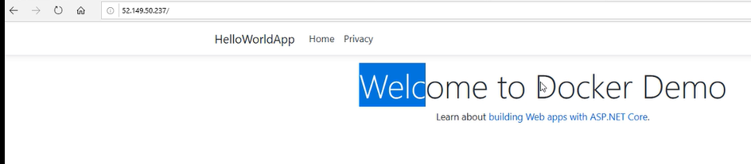

6-Creating a CI and CD Pipeline for Docker Image

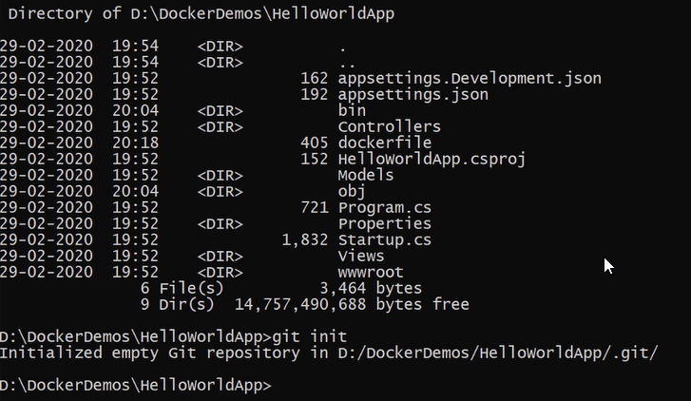

git add .

git commit -m” this is the new one”

s

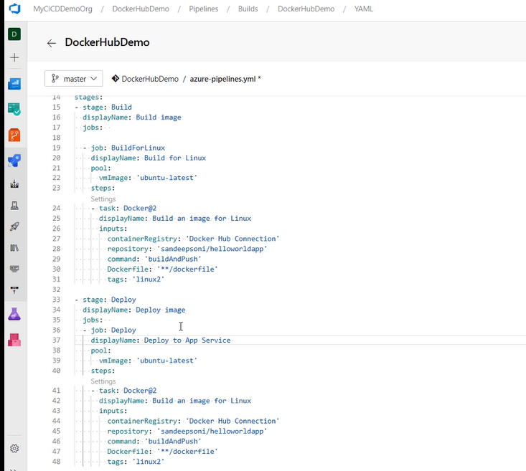

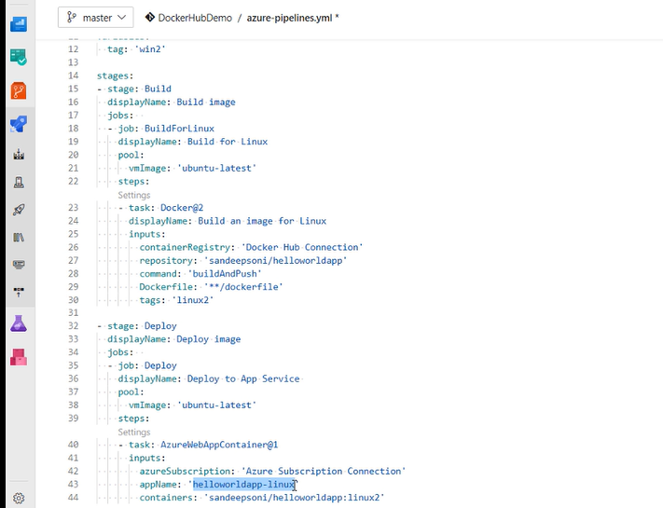

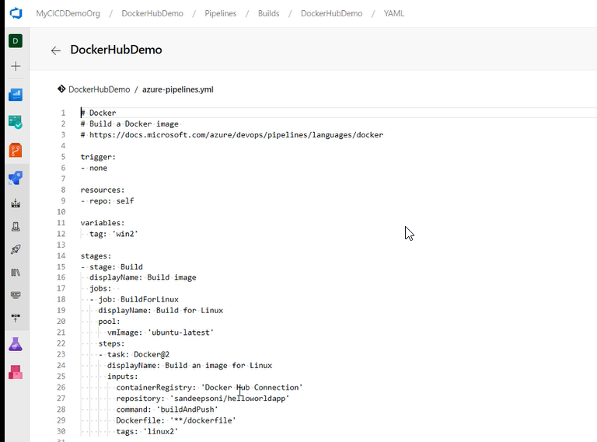

We don’t have process to give username and password in YAML and we need to give in the container settings

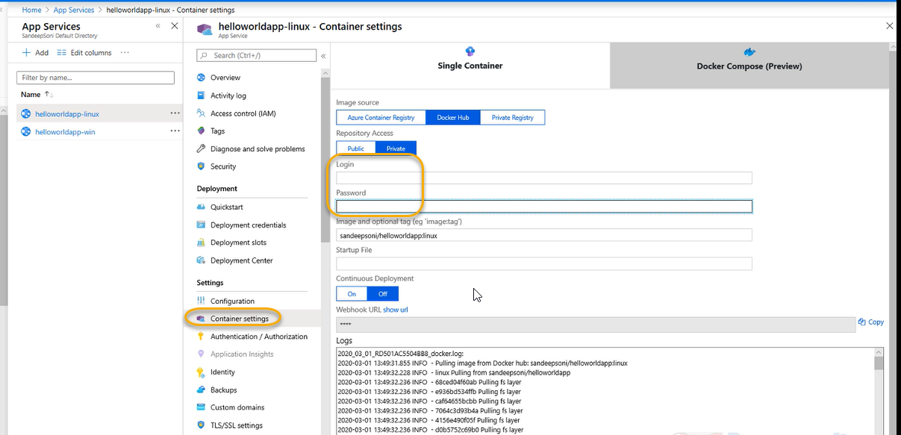

And now copy the URL from linux

